
EPH–International Journal of Humanities and Social Science

Published by: Southern Cross Academic Press
ISSN (Online): 2208-2174
Volume 11 Issue 01 April 2026

DEMOCRATIC GOVERNANCE AND CITIZEN PARTICIPATION: ASSESSING THE ROLE OF PUBLIC INSTITUTIONS IN SOCIAL DEVELOPMENT

Dr. Elena Markovic^{1*}, Dr. Ahmed El-Sayed^{2,} Dr. Maria Gonzalez-Sanchez³

^{1*}Department of Political Science University of Belgrade Belgrade, Serbia 📧 elena.markovic@fpn.bg.ac.rs
²Department of Public Administration Cairo University Cairo, Egypt
³Faculty of Social Sciences University of Granada Granada, Spain

ABSTRACT
This article examines the relationship between democratic governance, citizen participation, public institutions, and social development. It argues that democratic governance becomes socially meaningful only when citizens are able to participate in public decision-making and when public institutions are capable of responding to citizen needs. The study adopts a qualitative thematic research design based on secondary data. It draws on selected institutional reports and scholarly literature related to governance, civic engagement, open government, participatory development, accountability, and public service delivery. Thematic analysis was used to identify recurring patterns concerning institutional accountability, levels of participation, inclusion, public trust, digital engagement, service responsiveness, and barriers to meaningful participation. The findings show that citizen participation can strengthen accountability, improve service delivery, enhance public trust, and support inclusive social development. However, the impact of participation depends on institutional transparency, administrative capacity, civic awareness, and the extent to which citizen input influences actual decisions. The analysis also shows that participation may become symbolic when public institutions lack responsiveness or when marginalized groups face social, political, economic, or digital barriers. The article concludes that public institutions play a decisive mediating role between democratic participation and social development outcomes. Strengthening participatory governance therefore requires accountable institutions, inclusive engagement mechanisms, effective grievance redressal, accessible information, civic education, and digital participation systems that do not reproduce existing inequalities.

Article History:

Received Date: 22/02/2026 Revised Date: 26/03/2026 Accepted Date: 04/04/2026 Published Date: 11/04/2026
Keywords: Democratic governance; Citizen participation; Public institutions; Social development
1. Introduction
The notion of democracy in governance is being seen as an exercise of participation by the citizens rather than the implementation of a framework of rules that guide elections. In the context of modern governance theory, citizen participation becomes an essential element in promoting a sense of legitimacy, responsiveness, and social relevance of the decision-making process. By engaging in citizen participation, people express their concerns, influence planning, and exert power to make sure that the public organizations are held responsible for their actions. This is particularly important in the case of local government since decisions about infrastructure development, welfare services, healthcare, education, environment, and other community-based sectors affect citizens' lives. Thus, according to Abas et al. (2023), public participation has become an integral element of local government decision-making and planning, as it helps public organizations to align their policies with community interests.
The increasing emphasis on participatory governance corresponds to the changing understanding of democracy and how it should function. Participatory governance is meant to expand the scope of democratic activity, creating spaces for deliberative discussions among citizens, civil society, and public agencies regarding decisions making and implementation. Thus, Bua and Bussu (2021) identify participatory governance and democratic transformation as interconnected concepts. In addition, Bussu et al. (2022) define participatory governance as a rapidly developing area of study within democratic governance research. It is related to such notions as inclusion, voice, deliberation, and institutional responsiveness. Overall, the above ideas indicate the need to reconsider democratic governance assessment in terms of not only political rights but also citizen influence on public policy.
Citizen participation holds considerable significance in the context of political trust. Political trust is based on perceptions regarding the quality of governance, its openness and responsiveness to citizens' concerns. For instance, Holum (2023) examines connections between government action, citizen participation, and trust in local politicians. Participatory action can serve as a basis for increasing trust if citizens perceive their participation as being impactful. Likewise, Ardanaz et al. (2023) have demonstrated that even information about citizen participation programs can help to increase political trust provided that citizens perceive that institutions give them chances for participation. Public trust depends not only on the quality of governance but also on the provision of credible public information. Mansoor (2021) has found a strong connection between public trust and good governance and quality public information. According to Mansoor, transparency and responsiveness are key preconditions for legitimate public administration.

Participatory governance also requires the presence of certain institutional and civic capacities. First of all, effective participation necessitates institutional capacity to manage the process and to involve citizens. Second, citizens need to have appropriate capacity in order to become participants. Specifically, they must have sufficient access to information, be well aware of their rights and the possibility of participation, and be confident enough to take part in the activity. Vivier and Sanchez-Betancourt (2023) conceptualize participatory governance as a framework that includes institutional and civic capacities. This approach is important since participatory governance tends to fail when not embedded into the standard decision-making process. Paliokaitė and Sadauskaitė (2023) underscore the importance of institutionalizing participative and collaborative governance, while Kurkela et al. (2024) find that citizen participation is an organizational challenge to be faced by local governments. Therefore, participation is both a normative goal and a practical one at the same time.
The trend toward the adoption of open government and digital governance expands the scope of opportunities for citizen participation. Nowadays, open government includes more elements than transparency, participation, and collaboration. Gil-Garcia et al. (2020) argue that it is essential to consider broader dimensions in relation to open government, including the use of data, technology, institutional aspects, and creation of public value. Digitization becomes a key approach to improving public service delivery and participation. For example, Adnan et al. (2022) place e-participation in the context of e-government initiatives and emphasize the importance of using electronic channels for communication and consultation. Digitalization opens up new ways of participation for citizens in the smart city environments, who can easily communicate with institutions and participate in the management of cities with the help of special applications and tools. Bastos et al. (2022) discuss the role of smart city applications in increasing citizen participation.
Digitization is recognized as an element facilitating transformations of public services. Latupeirissa et al. (2024) point out that digitization has an enormous potential to transform public administration by improving the service process and enhancing institutional performance. Citizen experiences in the area of digital service delivery are critical since such initiatives can create public value if they are accessible, responsive, reliable, and aligned with citizens' needs. Luna et al. (2024) maintain that digital service delivery should be considered from the point of view of public value created by it for citizens. Furthermore, Shin et al. (2024) mention increasing trends in using digital tools for citizen participation, including various types of consultation, crowdsourcing, feedback, and collaborative work.
However, there exists another important issue that cannot be overlooked. Namely, it is not enough merely to establish participatory instruments since they cannot ensure effective participation and social development. Public consultation can turn into symbolic politics, digital tools used in citizen participation can be exclusive to citizens without necessary access and skills, and the problem of lack of institutional capacity can prevent participation from taking place. It means that citizen participation may not lead to social development. In this context, the major issue that should be discussed in the present study is how public institutions ensure the quality and effectiveness of citizen participation in democratic governance.

2. Methodology
2.1 Research Design
The current study uses the qualitative thematic research methodology to explore the connection between democracy, citizen participation, institutions, and social development. This paper is based on secondary sources and employs the documentary method for data collection. Since the purpose of the study does not entail quantitative analysis but conceptualization and interpretation of the concept at hand, the methodology will focus on extracting relevant themes from the institutional reports and academic literature considered in the research. The justification for adopting the qualitative methodology is that the variables of interest in the study, i.e., democracy and citizen participation, are multifaceted concepts.

2.2 Data Sources
Thematic analysis will be conducted on the basis of eight completed secondary sources as the primary data collection for research purposes. The sources consist of international development institution reports and scholarly articles. The World Development Report 2017: Governance and the Law from the World Bank will be used to explain the connection between the concepts of governance, laws, institutional capability, power, and development impact (World Bank, 2017). Moreover, the World Bank report about civic/citizen engagement will be used to understand citizenship-state relations, participatory mechanisms, and the role of engagement in improving development performance (World Bank, n.d.). At the same time, the UNDP report on civic engagement will be explored to evaluate participation, public spheres inclusiveness, and citizen involvement in the democratic process (United Nations Development Programme [UNDP], n.d.).
Additionally, the UN DESA paper on participation and accountability will be used to analyze the questions of transparency, accountability, public administration, and citizen-centric governance (United Nations Department of Economic and Social Affairs [UN DESA], n.d.). The open government report from OECD will be examined to explore the topics of transparency, integrity, accountability, stakeholder participation, and democratic resilience in public institutions (OECD, 2023). Finally, the well-known paper by Arnstein about the ladder of citizen participation will be used to distinguish between symbolic participation and actual one (Arnstein, 1969). Moreover, Gaventa and Barrett's study will be used to explore the outcomes of citizen participation focusing particularly on the democratic and developmental impacts of such process (Gaventa & Barrett, 2012). Finally, the study on participatory development from Mansuri and Rao will be analyzed to critically evaluate local participation, institutional design, elite capture, and problems of induced participation (Mansuri & Rao, 2013).

2.3 Source Selection Criteria
Purposive sampling was applied in selecting the sources. Each source was selected depending on its relevancy to one of the key themes explored in the paper; that is, democracy, civic engagement, institutions, accountability, participation, good governance, and social development. Reports by institutions were selected based on their policy orientation and comparative approach to governance and development. Academic sources were also selected depending on their theoretical and empirical contributions to the subject of citizen participation in development and governance. The combination of institutional and academic sources will allow creating a balanced framework of themes.

2.4 Method of Analysis
For the interpretation of the sources selected, a thematic analysis will be applied. In the first place, the sources will be reviewed for any recurring concepts associated with democratic governance, accountability, citizen participation, responsiveness of institutions, inclusivity, and social development. Then, similar concepts will be organized according to their themes. Lastly, these themes will be discussed in connection with the research aims. Some of the major themes that will be examined include democratic governance and institutional accountability, citizen participation, citizen engagement, public institutions and their services, marginalization, participation barriers, and institutional reforms for social development.

2.5 Analytical Framework
The research will be done under the framework where the assumption is made that democracy and governance serve as the moral grounds through which citizen participation can achieve social development, and the role of the institutional context is that of mediator between participation and development. According to this framework, citizen participation can help promote social development where there is transparency, accountability, inclusiveness, and responsiveness among the institutions involved. In order to measure the degree of citizen participation, Arnstein’s model will be used together with institutional sources. (Arnstein, 1969; OECD, 2023; World Bank, 2017).

3. Results
Theme-based analysis of the selected secondary sources reveals some key findings relating to democracy, citizenship, public organizations, and social development. Considering that this research involves the use of documentary and theoretical analysis, the findings can only be provided through major themes and not statistical data. It is found that the role of participation in social development is more pronounced when the public organization is accountable, transparent, inclusive, and responsive. On the other hand, it must also be noted that the existing literature shows how participation can become mere window dressing in cases where the institutional process is poorly organized.

3.1 Democratic Governance as an Institutional Foundation for Social Development
First and foremost, the main theme found in the review is that democratic governance does not only depend on elections but rather the efficiency and performance of institutions. Institutional capability and efficiency define governance within a development context because institutions are capable of ensuring the execution of policies, provision of public services, protection of rights and addressing citizens' demands. According to the World Bank (2017), governance depends on the way power is wielded through institutions, rules and decisions. Therefore, social development emerges through implementation, institutional efficiency and accountability and not just declaration through policy making.

Public institutions such as local governments, welfare agencies, public health organizations, education officials, courts, planning authorities, and administrative offices serve as the functional interface between democracy and social development. Institutions define whether there will be development in welfare, inclusiveness, public trust and fair access to services. Democratic governance also relies on principles of open government such as transparency, accountability, integrity and participation according to the OECD (2023). Thus, the review indicates that democratic governance should be regarded as an ongoing process through institutions and not merely an election activity. Table 1 shows the main thematic contributions of the selected sources.

Table 1: Thematic Contribution of Selected Data Sources
Data source | Main focus | Contribution to the results
World Bank (2017) | Governance, law, power, and institutions | Shows that institutional quality and power relations shape development outcomes
World Bank (n.d.) | Civic and citizen engagement | Explains how citizen engagement strengthens development effectiveness and citizen-state relations
UNDP (n.d.) | Civic engagement and inclusive public sphere | Highlights inclusion, participation, and democratic civic space
UN DESA (n.d.) | Participation and accountability | Links citizen participation with transparency, accountability, and public administration
OECD (2023) | Open government and democracy | Connects transparency, integrity, accountability, and stakeholder participation with stronger democracies
Arnstein (1969) | Levels of citizen participation | Provides a framework to distinguish symbolic participation from meaningful citizen power
Gaventa and Barrett (2012) | Outcomes of citizen engagement | Demonstrates democratic and developmental outcomes of citizen participation
Mansuri and Rao (2013) | Participatory development | Provides a critical view of local participation, elite capture, and institutional design
As shown in Table 1, the reviewed sources collectively support the argument that social development requires more than formal democratic structures. It requires institutions that can translate participation into public action.

3.2 Citizen Participation as a Mechanism of Accountability
Theme Two: Participation is said to ensure accountability if citizens have access to information and can engage through proper means. This helps citizens keep watch of the public officials and assess their activities, give comments, suggestions, and demand for improvement in service delivery. The UN DESA (n.d.) argues that participation and accountability are essential elements of good public administration especially in situations where there is an interaction between the citizens and the government through transparent ways. Similarly, the World Bank (n.d.) refers to civic and citizen engagement as a method for achieving success through improvement of the interface between the citizens and the state.
It is argued in the review of literature that for the process of participation to bear fruit, the process needs to be institutionalized in a manner where there are formal ways through which citizens can make their voices heard. Some of these processes include consultation with the public, participatory budgeting, social audits, grievance redressal, community monitoring, town hall meetings, and e-feedback. Through such processes, citizens will get a chance to participate in matters of governance in ways other than voting. The literature review further indicates that even though participation can ensure accountability, the obligation of the public institutions should compel them to act. Figure 1 shows how democracy and citizen participation relate to social development.

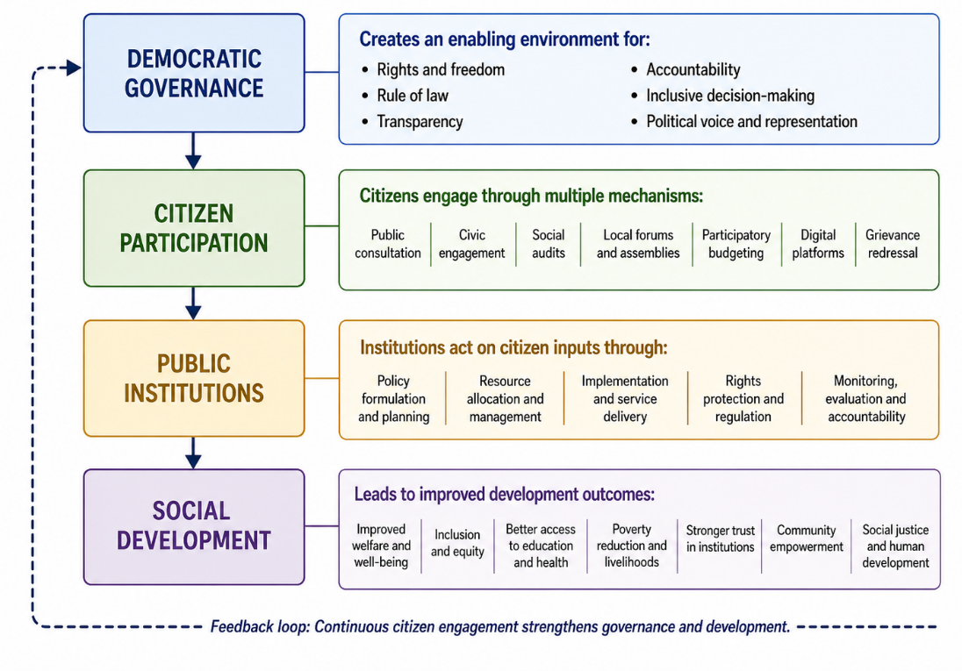
Figure 1: Conceptual Linkage Between Democratic Governance, Citizen Participation, Public Institutions, and Social Development

As shown in Figure 1, citizen participation acts as a bridge between democratic governance and social development, while public institutions function as the mediating structure that converts public voice into developmental outcomes.

3.3 Levels of Participation: From Tokenism to Meaningful Engagement
The third theme relates to the level of participation. As observed, the literature review shows that citizen participation is multi-level and includes symbolic participation and substantive citizen involvement. In this regard, it is useful to use the ladder of citizen participation developed by Arnstein (1969). It becomes evident that there exist types of participation that serve the purpose of informing or consulting citizens but do not provide real opportunities for decision-making. Substantive participation allows citizens to have an impact on organizational decisions and development.
Such information is important since there may be many democratic organizations where people can participate but cannot influence decisions. Participatory practices may be implemented in order to fulfill procedural obligations, which means that participation remains purely formal. Mansuri and Rao (2013) also note that participatory development programs can be hindered by elite capture, weak local capabilities, poor design, and lack of downward accountability.
Therefore, one can state that citizen participation as a democratic principle depends on whether the opinions of citizens are considered or whether such opinions matter when making decisions and allocating resources.

Table 2: Levels of Citizen Participation and Their Developmental Implications
Level of participation | Nature of citizen role | Institutional condition | Likely social development implication
Information sharing | Citizens receive information from institutions | One-way communication | Limited impact; improves awareness but not influence
Consultation | Citizens provide opinions or feedback | Institutions may or may not respond | Moderate impact if feedback is considered
Involvement | Citizens participate in discussions and planning | Regular interaction with institutions | Can improve local relevance of policies
Collaboration | Citizens and institutions jointly design or monitor programmes | Shared responsibility and institutional openness | Stronger accountability and better service delivery
Citizen power | Citizens influence decisions, budgets, and implementation | High accountability and decentralization | Strong potential for inclusive social development
According to Table 2, development significance is attained when participation rises from information exchange and consultation to collaboration and citizen empowerment. This result is consistent with Arnstein’s (1969) argument that genuine participation requires real power redistribution.

3.4 Public Institutions as Mediators of Social Development
Theme four suggests that there is an intermediary role played by the public institutions in the connection between participation and social development. Participation alone will not lead to development results without institutions having the capacity and ability to react. According to the World Bank (2017), the success of the policies is dependent on the institution's commitment, collaboration, and cooperation. Therefore, a participatory approach that is properly designed may be ineffective due to fragmented, non-responsive, and unequal relations of power in public institutions.
From the analysis, it becomes clear that public institutions affect social development via many ways. These institutions allocate the public budget, implement welfare programs, provide essential services, regulate the exercise of rights, and set up complaint processes. In cases where institutions are responsive, participation will improve targeting of services and increase inclusiveness. On the other hand, when the institutions are bureaucratic and centralized, there is no chance for development through participation. Table 3 highlights the main roles played by public institutions from the analysis.

Table 3: Public Institutional Functions and Their Role in Social Development
Institutional function | Description | Link with citizen participation | Development outcome
Policy formulation | Designing laws, plans, and development priorities | Citizens identify needs and policy gaps | More relevant and inclusive policies
Service delivery | Providing education, health, welfare, and public services | Citizens monitor access and quality | Improved responsiveness and service equity
Accountability mechanisms | Ensuring answerability and transparency | Citizens demand information and explanations | Reduced misuse of power and stronger trust
Grievance redressal | Addressing complaints and service failures | Citizens report problems and seek correction | Improved institutional responsiveness
Resource allocation | Distributing funds and public benefits | Citizens influence priorities through local participation | Better targeting of welfare and development schemes
Rights protection | Safeguarding legal and social rights | Citizens claim entitlements and challenge exclusion | Greater social justice and inclusion
As shown in Table 3, public institutions are not passive administrative structures. They actively determine whether citizen participation becomes a practical tool for social development.

3.5 Inclusion and Representation as Conditions for Participatory Development
Theme number five indicates the necessity of citizen participation as one of the main factors contributing to social development. According to the literature analysis, participation may be driven by certain aspects of social injustice. In particular, marginalized individuals experience various barriers related to poverty, gender inequality, caste, ethnicity, illiteracy, geographical isolation, disability, lack of information, and political consciousness. In accordance with the UNDP (n.d.), participatory activities are important in an open and inclusive public arena. In other words, participation should be accessible not only to well-established or powerful actors but also to those who are usually excluded from public discussions.
As explained by Gaventa & Barrett (2012), participatory processes may contribute to social democracy and development; however, these outcomes cannot be regarded as automatic. Successful participation requires some conditions, including citizen competencies, responsiveness of institutions, and inclusiveness. Similarly, according to Mansuri and Rao (2013), participatory approaches to development may become useless if local elites control decision-making process. This means that in addition to being a normative necessity, inclusiveness is an essential condition of social development.

3.6 Barriers to Meaningful Citizen Participation
Theme six is about barriers to participation. Different barriers in institutions and society have been found during the literature review, including lack of information, lack of accountability, bureaucracy, elite dominance, lack of civic literacy, lack of institutional capacity, meaningless consultation, social marginalization, and technology divide. Collectively, these barriers restrict the use of participation as a way to ensure democracy. Figure 2 represents the summary of some of the identified barriers to participation.
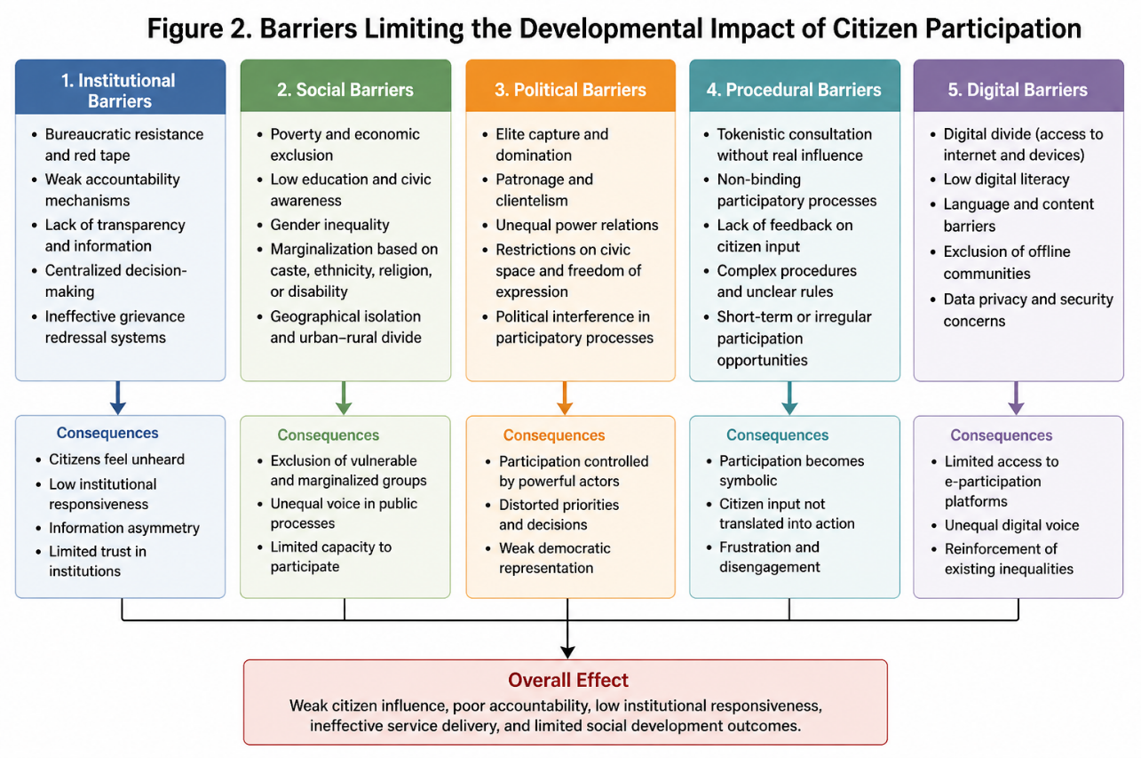
Figure 2: Barriers Limiting the Developmental Impact of Citizen Participation

As shown in Figure 2, the barriers to participation are multidimensional. They are not limited to citizen apathy but are also embedded in institutional design, political power, and social inequality.

3.7 Open Government and Digital Participation as Emerging Tools
Theme seven relates to the growing importance of open government and digital participation. According to the OECD (2023), open government is seen as one way of strengthening democracies via transparency, accountability, integrity, and stakeholder engagement. Similar ideas regarding participation and accountability in public institutions have been expressed by UN DESA (n.d.), which emphasizes the importance of digital tools and information accessibility.
According to the analysis, digital technology could increase the range of options for citizens to provide feedback, participate in consultations, submit complaints, gain access to information, and monitor services provided. At the same time, digital participation cannot replace institutional participation because, if digital platforms are adopted without resolving issues of access, literacy, language, disability, and connectivity, they might even exacerbate existing problems. Therefore, digital participation should be considered as an additional tool in the institutions' arsenal.

3.8 Summary of Thematic Results
The critical point in the study, therefore, is that democracy facilitates social development by way of citizen participation through institutional mechanisms. Public institutions once more come into play because their interventions determine whether citizenry is silenced, given symbolic recognition, or translated into concrete policy-making processes. Last, in light of the thematic content analysis framework, the findings indicate that citizen participation is not a necessary cause of social development. On the contrary, it is dependent on the existence of accountable, transparent, engaged, inclusive, and empowered citizenry.
Thus, these findings lend weight to the core argument put forward in the article, that citizen participation will serve as an engine for social development if and only if public institutions are structured appropriately.

4. Discussion
An assessment of the existing literature on this research theme reveals that there exists a positive relationship between democratic governance and social development, but only if there is institutionalization of participation by the people. From the findings of the study, it can be concluded that participation goes beyond the abstract notion of democratic governance and becomes a process that involves institution-driven citizens who define their needs, evaluate services, hold authorities accountable, and set priorities for development. This interpretation is coherent with current literature suggesting that people's interest to participate depends on institutional performance, effectiveness, and trustworthiness. As the literature shows, citizens are willing to participate in processes if they perceive public institutions as effective, accountable, and reliable. However, lack of trust and low effectiveness of institutions reduce the willingness to participate (Ati et al., 2024).
One key implication of the results for policy practice is that participation should be institutionalized in order to promote good governance. It was found that institutional participatory measures such as public consultations, social auditing, local forums, grievance redress mechanisms, participatory budgeting, and digital participation improve the institutional quality by making institutions more accountable and responsible for their actions. Nevertheless, these measures lead to desirable outcomes only when institutions respond to the demands expressed by citizens. Since citizens are familiar with local problems and priorities, citizen participation may help to align public policies with real-life social needs and improve the implementation of development strategies (Ozaki & Shaw, 2022).
The results further indicate that the participatory budgeting process is among the clearest ways in which the involvement of citizens in decision-making can affect social development. Through participatory budgeting, people are able to engage in deliberation about community concerns, shape budget decisions, and oversee the use of government resources. This will promote development at the local level due to greater responsiveness to the needs of the community. According to Schugurensky and Mook (2024), this approach to decision-making can be employed for learning, empowerment, and community development purposes. On the other hand, participatory budgeting also poses some constraints. Its success depends on a number of factors, including institutional engagement, awareness among the citizens, administrative capacity, and implementation of citizen decisions. Bartocci et al. (2023) raise similar issues with respect to participatory budgeting.
Another critical issue that arises from the findings is the importance of citizens as co-producers of governance outcomes. Participation is not only confined to consultation but can also include citizens in designing, implementing, monitoring, and evaluating public services. Co-production is vital at the community level since the involvement of citizens is crucial in solving public problems due to the dependence of public institutions on citizen expertise and collaboration. According to Wu and Xiong (2022), co-production enhances community governance through greater citizen engagement in solving public problems. Thus, the finding that public institutions are mediating structures between citizen voice and social development indicates that institutionalized co-production leads to sensitive and responsive developmental outcomes.
Further, the findings showed that accountability is indispensable in fostering meaningful participation. Social accountability interventions can help citizens monitor institutions, demand explanations, and have an impact on service delivery. Osei-Kufuor et al. (2024) underscore that social accountability enhances local governance when citizens are provided with tangible means to challenge those in authority and institutions are open to responding to citizens' queries. However, mechanisms of accountability may be ineffective when citizens lack information, officials are not accountable, and participation spaces are elite-dominated. This finding corroborates the result that participation will be symbolic without institutional reforms.
Another critical issue is inclusion. Findings indicate that marginalized groups may experience several challenges in participating in decision-making processes, such as poverty, lack of education, gender discrimination, digital divide, and social exclusion. Therefore, any form of participation must be made possible for women, youth, the poor, minorities, rural communities, and other disadvantaged groups. According to Sánchez-Soriano et al. (2024), inclusive governance is linked to community empowerment and social justice. Consequently, participation promotes social development only if it eliminates exclusion instead of reinforcing it.
Citizen participation also holds relevance for the topic of innovation within the public sector. Citizens' engagement with their institutions can help identify service problems, experiment with new solutions, and improve policy-making process. According to Nguyen et al. (2024), citizen engagement plays a role in public sector innovation by allowing institutions to learn from citizens and their experiences. The finding is pertinent to the current research as social development necessitates adaptive institutions capable of reacting to changes in citizen needs.
Another important issue associated with citizen participation is digital participation. Digital transparency portals, crowdsourcing mechanisms, online consultations, and e-participation platforms can contribute to increasing participation rates and ensuring greater access to information. Specifically, according to Zhao et al. (2023), digital transparency platforms and crowdsourcing mechanisms may influence citizen participation by making public information available and opening additional channels of public participation. In addition, digital participation may negatively affect some groups of citizens by excluding those who do not have access to the internet or have no knowledge about how to use online platforms properly. To address such concerns, Mariani et al. (2023) recommend applying design thinking approaches to make online platforms accessible for people.
In conclusion, the above discussion proves the main idea of the article: namely, that citizen participation can become an impetus for social development only if public institutions act transparently, inclusively, responsibly, and responsively. Thus, citizen participation without active participation of institutions can turn into a mere formality, whereas institutions themselves can become alienated from the citizens if citizens themselves do not get involved.

5. Conclusion
It can be concluded that democratic governance, participation, public institutions, and social development are related to each other. Democratic governance lays down the normative framework of rights, accountability, transparency, and public voice, whereas participation translates the same into practice. It is clear from this article that social development can be achieved through participatory practices only if there are effective, transparent, and citizen-oriented public institutions. Public institutions serve as an intermediary between the demands of citizens and development outcomes. Formulation of policies, delivery of services, resource allocation, protection of rights, handling grievances, and accountability are some of the important roles performed by these institutions. If public institutions are transparent and citizen-friendly, then participation can have several positive impacts like improved trust, quality of services, inclusion, delivery of welfare schemes, and community mobilization. On the contrary, if these institutions are weak, centralized, exclusive, and non-responsive to the views of the citizens, then participation would be more symbolic than substantive. This article also demonstrates that there exists a difference among different types of participatory practices. Formal consultations, public meetings, or the use of internet-based technologies may give rise to the illusion of participation without any power to influence developmental priorities. Thus, democratic participation should not remain at the level of mere representation and should include collaboration, co-production, and decision-making processes as well. Similarly, participation requires inclusion as there are many social, economic, political, and digital constraints to it on the part of marginalized sections. In general, it can be argued that participation cannot be viewed just from the perspective of a democratic right; rather it should be seen as a development strategy as well. This requires public institutions that are accountable, transparent, educated, and responsive towards the voices of citizens.

References
- Abas, A., Arifin, K., Ali, M. A. M., & Khairil, M. (2023). A systematic literature review on public participation in decision-making for local authority planning: A decade of progress and challenges. Environmental Development, 46, 100853.
- Adnan, M., Ghazali, M., & Othman, N. Z. S. (2022). E-participation within the context of e-government initiatives: A comprehensive systematic review. Telematics and Informatics Reports, 8, 100015.
- Ardanaz, M., Otálvaro-Ramírez, S., & Scartascini, C. (2023). Does information about citizen participation initiatives increase political trust?. World Development, 162, 106132.
- Arnstein, S. R. (1969). A ladder of citizen participation. Journal of the American Institute of Planners, 35(4), 216–224. https://doi.org/10.1080/01944366908977225
- Ati, S., Satpathy, S., & Saxena, S. (2024). Perceived public service performance, trust in the government, and citizens' willingness to participate: Evidence from water governance in Visakhapatnam, India. Water Policy, 26(6), 618-634.
- Bartocci, L., Grossi, G., Mauro, S. G., & Ebdon, C. (2023). The journey of participatory budgeting: a systematic literature review and future research directions. International Review of Administrative Sciences, 89(3), 757-774.
- Bastos, D., Fernández-Caballero, A., Pereira, A., & Rocha, N. P. (2022, October). Smart city applications to promote citizen participation in city management and governance: A systematic review. In Informatics (Vol. 9, No. 4, p. 89). MDPI.
- Bua, A., & Bussu, S. (2021). Between governance‐driven democratisation and democracy‐driven governance: Explaining changes in participatory governance in the case of Barcelona. European Journal of Political Research, 60(3), 716-737.
- Bussu, S., Bua, A., Dean, R., & Smith, G. (2022). Introduction: Embedding participatory governance. Critical Policy Studies, 16(2), 133-145.
- Gaventa, J., & Barrett, G. (2012). Mapping the outcomes of citizen engagement. World Development, 40(12), 2399–2410. https://doi.org/10.1016/j.worlddev.2012.05.014
- Gil-Garcia, J. R., Gasco-Hernandez, M., & Pardo, T. A. (2020). Beyond transparency, participation, and collaboration? A reflection on the dimensions of open government. Public Performance & Management Review, 43(3), 483-502.
- Holum, M. (2023). Citizen participation: Linking government efforts, actual participation, and trust in local politicians. International Journal of Public Administration, 46(13), 915-925.
- Kurkela, K., Kork, A. A., Jäntti, A., & Paananen, H. (2024). Citizen participation as an organisational challenge in local government. International Journal of Public Sector Management, 37(1), 124-140.
- Latupeirissa, J. J. P., Dewi, N. L. Y., Prayana, I. K. R., Srikandi, M. B., Ramadiansyah, S. A., & Pramana, I. B. G. A. Y. (2024). Transforming public service delivery: A comprehensive review of digitization initiatives. Sustainability, 16(7), 2818.
- Luna, D. E., Picazo-Vela, S., Buyannemekh, B., & Luna-Reyes, L. F. (2024). Creating public value through digital service delivery from a citizen's perspective. Government Information Quarterly, 41(2), 101928.
- Mansoor, M. (2021). Citizens' trust in government as a function of good governance and government agency's provision of quality information on social media during COVID-19. Government information quarterly, 38(4), 101597.
- Mansuri, G., & Rao, V. (2013). Localizing development: Does participation work? World Bank. https://www.worldbank.org/en/research/publication/localizing-development-does-participation-work
- Mariani, I., Mortati, M., & Rizzo, F. (2023, July). Strengthening e-Participation through Design Thinking. Relevance for Better Digital Public Services. In Proceedings of the 24th Annual International Conference on Digital Government Research (pp. 224-232).
- Nguyen, H., Drejer, I., & Marques, P. (2024). Citizen engagement in public sector innovation: exploring the transition between paradigms. Public Management Review, 26(12), 3622-3642.
- OECD (2023), Open Government for Stronger Democracies: A Global Assessment, OECD Publishing, Paris, https://doi.org/10.1787/5478db5b-en.
- Osei-Kufuor, P., Tenkorang, E. Y., Koomson, F., & Ntiri, R. O. (2024). Assessing the effectiveness of social accountability interventions in selected district assemblies in Ghana. Cogent Social Sciences, 10(1), 2371673.
- Ozaki, Y., & Shaw, R. (2022). Citizens’ social participation to implement sustainable development goals (SDGs): A literature review. Sustainability, 14(21), 14471.
- Paliokaitė, A., & Sadauskaitė, A. (2023). Institutionalisation of participative and collaborative governance: Case studies of Lithuania 2030 and Finland 2030. Futures, 150, 103174.
- Sánchez-Soriano, M., Arango-Ramírez, P. M., Pérez-López, E. I., & García-Montalvo, I. A. (2024). Inclusive governance: empowering communities and promoting social justice. Frontiers in Political Science, 6, 1478126.
- Schugurensky, D., & Mook, L. (2024). Participatory budgeting and local development: Impacts, challenges, and prospects. Local Development & Society, 5(3), 433-445.
- Shin, B., Floch, J., Rask, M., Bæck, P., Edgar, C., Berditchevskaia, A., ... & Branlat, M. (2024). A systematic analysis of digital tools for citizen participation. Government Information Quarterly, 41(3), 101954.
- United Nations Department of Economic and Social Affairs. (n.d.). Participation and accountability. United Nations Public Institutions. https://publicadministration.desa.un.org/topics/participation-and-accountability
- United Nations Development Programme. (n.d.). Civic engagement. UNDP. https://www.undp.org/governance/open-and-inclusive-public-sphere/civic-engagement
- Vivier, E., & Sanchez‐Betancourt, D. (2023). Participatory governance and the capacity to engage: A systems lens. Public Administration and Development, 43(3), 220-231.
- World Bank. (2017). World development report 2017: Governance and the law. World Bank. https://www.worldbank.org/en/publication/wdr2017
- World Bank. (n.d.). Civic and citizen engagement. World Bank Group. https://www.worldbank.org/ext/en/topic/social-development/citizen-engagement
- Wu, J., & Xiong, J. (2022). How governance tools facilitate citizen co-production behavior in urban community micro-regeneration: evidence from Shanghai. Land, 11(8), 1243.
- Zhao, B., Cheng, S., Schiff, K. J., & Kim, Y. (2023). Digital transparency and citizen participation: Evidence from the online crowdsourcing platform of the City of Sacramento. Government Information Quarterly, 40(4), 101868.

