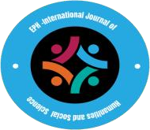
EPH–International Journal of Humanities and Social Science

Published by: Southern Cross Academic Press
ISSN (Online): 2208-2174
Volume 11 Issue 01 April 2026

DIGITAL LIFESTYLES AND SOCIAL OUTCOMES: A CROSS-SECTIONAL ANALYSIS OF SOCIAL MEDIA USAGE PATTERNS

^{1.} Dr. Hannah J. Collins, ^{2.} Dr. Rajiv Mehta

^{1*}Department of Digital Sociology and Media Studies University of Amsterdam Amsterdam, Netherlands Email: h.collins@uva.nl
²School of Information and Communication Technology Indian Institute of Technology Delhi
New Delhi, India Email: rajiv.mehta@iitd.ac.in

ABSTRACT
The study examines the relationship between digital lifestyles and social outcomes, focusing on how social media usage patterns influence psychological well-being and social behavior. Using a quantitative cross-sectional design and secondary data from a Kaggle dataset (N = 705), the study analyzes key variables including daily usage duration, sleep patterns, mental health, social conflicts, and addiction levels. Descriptive statistics, correlation analysis, and multiple regression models were employed to assess associations and predictive relationships. The findings reveal that higher social media usage is significantly associated with increased addiction (β = 0.066, p < 0.01), greater interpersonal conflicts (β = 0.487, p < 0.001), and negative academic impact (β = 0.596, p < 0.001), while showing strong negative relationships with sleep duration (β = -0.174, p < 0.001) and mental health (β = -0.585, p < 0.001). A secondary model confirms that excessive usage and conflict significantly reduce mental health, whereas adequate sleep improves it. The study contributes to digital sociology by providing an integrated framework linking usage patterns with multidimensional social outcomes. The results highlight the importance of balanced digital engagement and inform policy and educational strategies aimed at promoting digital well-being.
.

Article History:

Received Date: 22/02/2026 Revised Date: 26/03/2026 Accepted Date: 04/04/2026 Published Date: 11/04/2026
Keywords: Digital lifestyles, social media usage, mental health, social outcomes, digital well-being
- Introduction
The high rate of growth of digital technologies and social media platforms have fundamentally transformed the modern social organization, communication patterns, and everyday life patterns. In the last ten years, the platforms like Facebook, Instagram, and Tik Tok have developed into the main arenas of interaction, exchange of information, and development of identities. These platforms help people overcome geographical and cultural barriers in their social interactions in real-time and globally (George, 2025; Ejinwa, 2021). Consequently, social media is no longer a simple communication tool but a multifaceted socio-technical structure that has an impact on political discourse, cultural production, and economic behavior. This change has also seen the shift in the pattern of media consumption whereby users have increasingly utilized the digital platforms to get their news, entertainment, education and interpersonal communication. These changes have far-reaching consequences on the identity of culture and social relationships as individuals constantly bargain their identities in digitally mediated spaces (Sutrisno, 2023). In this context, the notion of digital lifestyles has become a significant analytical tool, as it captures how people incorporate digital technologies in their lives, values, and social lives (Azizah, 2025).
Although there is a general move towards the incorporation of social media into everyday life, the effects that social media has on social well-being are still highly controversial. On the one hand, social media platforms are linked to the positive effects that include: improved connectivity, access to more information, and the possibility to express yourself. There is empirical evidence that the use of social media can result in a social interaction and create a psychological well-being by providing the user with an opportunity to stay in touch with others and rely on supportive communities (Mitev et al., 2021). Conversely, an increasing number of studies indicate that the adverse effects of social media use could be more significant than expected, with the lack of social communication and interaction with people being the most detrimental outcomes (Pugno, 2025). This difference in findings suggests an even more conceptual problem in the literature, in which the relationship between social media use and social outcomes is often approached in a simplistic or unidimensional fashion. The use of social media in reality is multifaceted in nature and it entails the variations in intensity, purpose and mode of engagement. Theoretical approaches like the media system dependency theory further indicate that the rising dependence on digital platforms can change communication practices and interpersonal relationships, both positively and negatively depending on the nature of use (Kim and Jung, 2017; Youssef et al., 2024). Though the amount of scholarly interest in social media has grown significantly, there are still vital gaps in the knowledge about its greater implications to society. The current body of research is limited in its ability to generalize the results and in its capacity to consider the complexity of multi-platform interaction. Also, most studies tend to study social outcomes such as well being, social capital and academic or professional performance in isolation, as opposed to the interconnected nature of these social outcomes. This piecemeal process limits the formation of holistic frameworks that are able to capture the entire magnitude of digital behavior and its outcomes. Moreover, it is characterized by a significant absence of cross-sectional, comparative datasets, which are sufficiently representative of various socio-economic and cultural conditions, especially in the Global South, where the adoption of digital technologies is rapidly growing and playing a key role in the social and economic development (Awodiya, 2025). It is in this vein that there is an urgent need to have integrative, data-driven research that systematically looks at the relationship between the pattern of social media use and social outcomes. This research satisfies this need by making contributions to both disciplines of digital sociology and behavioral science, through a multidimensional exploration of digital lifestyles. It offers the development of abstract knowledge, practical knowledge as well, relating the patterns of use and various social impacts. Digital lifestyles multidimensional analysis. It offers the further development of the theoretical knowledge, and practical information, by bridging the patterns of utilization and various social outcomes. The results will likely inform policymakers, educators, and other stakeholders interested in issues of digital governance, especially when it comes to creating strategies that promote healthy digital engagement and alleviate potential dangers of excessive or unregulated use of social media (Landri, 2018; Williamson, 2016).

Research Objectives
- To analyze social media usage patterns across demographic groups
- To examine the relationship between social media use and social outcomes
- To identify key predictors of positive and negative social outcomes

2. Methodology
2.1 Research Design
The research design utilized in this study is a quantitative, cross-sectional study design to examine the relationship between the pattern of social media use and social outcomes. The cross-sectional approach makes it possible to examine a number of variables at one point in time thus making it possible to identify the associations between digital behavior and social indicators. The design especially fits well in large-scale secondary data where one is not able to track time. Although it does not determine causality, it offers strong indications of existing relationships. The methodology complies with the best practices in digital sociology and behavioral studies.

2.2 Data Source and Sample Selection
The research applies a secondary dataset obtained on Kaggle which is anonymized data on the use of social media. The data set covers data on demographic features, usage habits, as well as indicators of social outcomes. A data screening procedure was undertaken to guarantee quality and relevance wherein incomplete or inconsistent records were filtered out. The last sample is a valid observation that can be statistically analyzed. The dataset provides the adequate variability of demographic and behavioral variables, which is why it can be used to investigate the patterns of digital lifestyles (Aminasalamt,2025).

2.3 Variables and Measurement
The patterns of social media use are operationalized and used as independent variables with the indicators being the amount of time, the frequency, and the purpose of their engagement. Dependent variables include measures of social outcomes, such as well-being, quality of social interaction, and academic or professional performance. They include demographic factors such as age, gender and education level that are used as control variables. Variables are determined by relevance to the theory and previous literature. This operationalization makes sure that not only the behavioral but also the outcome dimensions are systematically captured.

2.4 Data Processing and Preparation
Preprocessing of the data: The cleaning, transformation, and validation processes were carried out to guarantee accuracy in the analytics. The missing values were addressed with appropriate and reasonable imputation of the missing data or with deletion of the missing data (where necessary). Statistical thresholds and the outliers were used to identify the outliers and to treat them in a way that ensures that no distortions are made to the results. The coded categorical variables were converted into numerical formats so that quantitative analysis could be done. The other that has been implemented where necessary is the application of the normalization and scaling processes in order to have consistency among the variables. The measures implemented made sure the dataset would be used to conduct a sound statistical modeling.

2.5 Analytical Techniques
The research will involve use of descriptive and inductive statistical tools. The analysis of summary of the demographic characteristics and patterns of use are summarized using descriptive statistics. The type of analysis carried out is the correlation analysis that is used to test the relationship between variables. The multiple regression analysis is used to evaluate the predictive power of social media usage to social outcomes controlling demographic aspects. To verify the validity of the model, diagnostic tests are carried out, such as checking the presence of multicollinearity and normality. In order to provide the justification of the sound interpretation of results, the test of statistical significance is evaluated at traditional level.

3. Results
3.1 Descriptive Statistics of Key Variables
Table 1 shows the descriptive statistics of the key variables, on which the analysis is performed. The findings show that the mean time spent on social media is about 4.92 hours a day, which indicates that the respondents engaged in social media use quite intensively. The average score of addiction (6.44) indicates moderate to high dependency levels. Also, the average mental health standing (6.23) denotes a mid-range psychological well-being position and the average sleep duration is about 6.87 hours.

Table 1: Descriptive Statistics of Key Variables
Variable | Mean | Std. Dev. | Min | Max
Age | 20.66 | 1.40 | 18 | 24
Avg_Daily_Usage_Hours | 4.92 | 1.26 | 1.5 | 8.5
Sleep_Hours_Per_Night | 6.87 | 1.13 | 3.8 | 9.6
Mental_Health_Score | 6.23 | 1.11 | 4 | 9
Conflicts_Over_Social_Media | 2.85 | 0.96 | 0 | 5
Addicted_Score | 6.44 | 1.59 | 2 | 9

3.2 Correlation Analysis
3.2.1 Relationships Between Social Media Usage and Social Outcomes
The r
esult of Table 2 is the correlation matrix of important variables. The findings indicate the strong positive correlations between average daily use and addiction scale (r = 0.83), as well as conflicts over social media (r = 0.80). On the other hand, the duration of sleep (r = -0.79) and mental health (r = -0.80) are strongly negatively correlated with usage as is shown in figure 1.

Table 2: Correlation Matrix
Variable | Usage | Sleep | Mental Health | Conflicts | Addiction | Academic Impact
Usage | 1.00 | -0.79 | -0.80 | 0.80 | 0.83 | 0.66
Sleep | -0.79 | 1.00 | 0.71 | -0.68 | -0.76 | -0.63
Mental Health | -0.80 | 0.71 | 1.00 | -0.89 | -0.95 | -0.81
Conflicts | 0.80 | -0.68 | -0.89 | 1.00 | 0.93 | 0.83
Addiction | 0.83 | -0.76 | -0.95 | 0.93 | 1.00 | 0.87
Academic Impact | 0.66 | -0.63 | -0.81 | 0.83 | 0.87 | 1.00

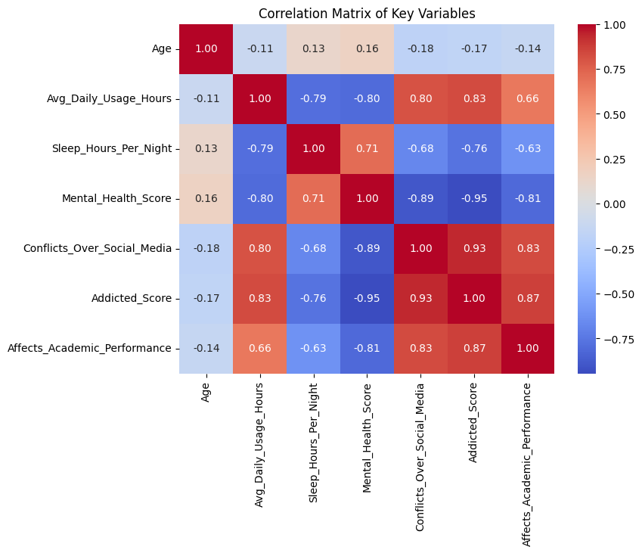
Figure 1: Correlation Matrix of Social Media Usage Patterns and Social Outcomes
3.3 Regression Analysis
3.3.1 Predictors of Social Media Addiction
The findings of the multiple regression model that predicts the score of addiction are reported in Table 3. The model accounts 95.3% of the variance (R² = 0.953) which is very strong explanatory power.

Table 3: Regression Results (Dependent Variable: Addicted Score)
Variable | Coefficient (β) | Std. Error | p-value
Constant | 9.199 | 0.369 | <0.001
Age | -0.001 | 0.009 | 0.925
Avg_Daily_Usage_Hours | 0.066 | 0.022 | 0.002
Sleep_Hours_Per_Night | -0.174 | 0.019 | <0.001
Mental_Health_Score | -0.585 | 0.029 | <0.001
Conflicts_Over_Social_Media | 0.487 | 0.036 | <0.001
Affects_Academic_Performance | 0.596 | 0.052 | <0.001

3.3.2 Predictors of Mental Health
To have a robust model, the second model was estimated with mental health as the dependent variable. Table 4 shows the results. The model explains 83.5% of the variance (R² = 0.835). Increased usage, conflicts, and academic disruption significantly reduce mental health, while sleep improves it.

Table 4: Regression Results (Dependent Variable: Mental Health Score)
Variable | Coefficient (β) | Std. Error | p-value
Constant | 8.366 | 0.366 | <0.001
Age | 0.004 | 0.012 | 0.747
Avg_Daily_Usage_Hours | -0.157 | 0.028 | <0.001
Sleep_Hours_Per_Night | 0.083 | 0.025 | 0.001
Conflicts_Over_Social_Media | -0.605 | 0.041 | <0.001
Affects_Academic_Performance | -0.462 | 0.065 | <0.001

3.4 Model Diagnostics
3.4.1 Residual Analysis and Normality
Examples of residual distributions and Q-Q plots show that there is an approximate normality with slight deviations at the tails. This indicates the assumptions of the regression are fairly met as demonstrated in figure 2 and 3.

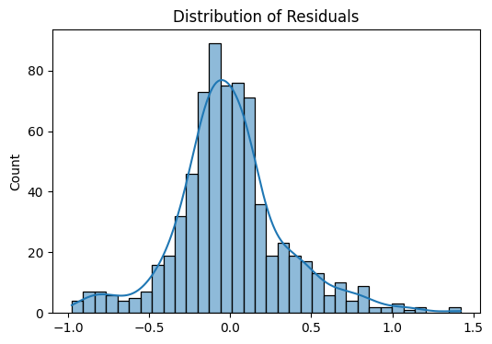
Figure 2: Distribution of Residuals for Regression Model
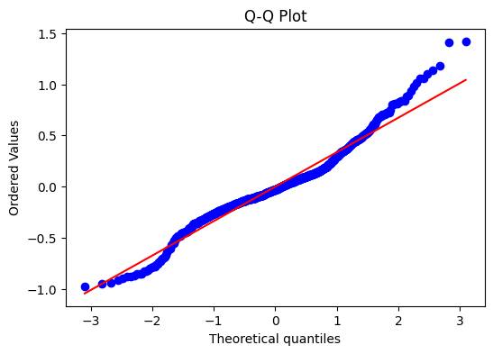
Figure 3: Normal Q–Q Plot of Standardized Residuals for Regression Model

3.4.2 Multicollinearity Assessment
The Variance Inflation Factor (VIF) values are in the table 5.

Table 5: Multicollinearity Diagnostics (VIF)
Variable | VIF
Age | 1.04
Avg_Daily_Usage_Hours | 4.44
Sleep_Hours_Per_Night | 2.86
Mental_Health_Score | 6.06
Conflicts_Over_Social_Media | 6.97
Affects_Academic_Performance | 3.64

3.5 Visualization of Key Relationships
The statistical results are also supported by the graphical analysis. The predicted vs actual plot shows the model is highly accurate as the observed values are very close to the predicted values. Also, regression plots indicate that there is a positive correlation between the time spent daily using it and addiction, and a positive association between sleep duration and mental health. Social media conflicts are closely correlated with increased addiction.

4. Discussion
The results of this study are compelling empirical evidence in support of the argument that digital lifestyles, especially patterns of intensive and unregulated use of social media are strongly correlated with negative social and psychological outcomes. The findings indicate that increased measures of daily social media use have a positive correlation with addiction and conflict and negative correlation with mental health and sleep duration. These results are consistent with the previous studies highlighting the dual nature of digital interactions where the advantages associated with digital engagement (such as connectivity) coexist with negative outcomes of digital interaction overuse and addiction (Nuzzaci and Maviglia, 2025; Annemans et al., 2024).
Theoretically speaking, the findings are extensions of media system dependency theory, which states that the more dependent people are on media systems, the more impactful they become on cognition, behavior, and social interactions of individuals (Zhang and Zhong, 2020). The positive strong relationship that was found between the use of social media, addiction and interpersonal conflicts indicates that the more dependent individuals are on the use of social media platforms, the more likely that their offline social relationships would be disrupted. This confirms the fact that media dependency is what will be determining the consumption of information as well as rearranging the social and behavioral patterns.
The negative relationship between the use of social media and mental health is apparent in the new literature on the digital well-being, which also highlights the psychological risks of excessive use of digital devices. Research has indicated that hyperconnectivity may cause cognitive overload, social comparison, and decreased emotional well-being (Burr et al., 2020; Stankov and Gretzel, 2021). The existing outcomes prove this perspective by demonstrating that current use and conflict significantly negatively impact on mental health scores, but that an adequate amount of sleep is a protective measure. This follows other frameworks suggesting a balanced digital interaction and promotion of healthy digital practices (Centeno et al., 2025).
The findings are also a contribution to the growing body of literature on lifestyle behavior in the digital era where the use of technology is becoming more of a normal way of life and a decision-making process. The usage intensity and purpose are significantly important and thus can support adaptive decision-making frameworks that might highlight the importance of context-sensitive digital behavior (Zhang et al., 2021). In this regard, the digital lifestyles cannot be seen in terms of the time spent online only, but as the complex patterns of behaviors, which overlap with the psychological and social variables.
The close association between conflicts that are related to social media and both addiction and mental health outcomes is especially noteworthy. This implies that the social effects of digital interaction, including interpersonal tensions and disagreements are critical in mediating the effect of technology on well-being. These findings are in line with recent debates about participatory and co-creative solutions to healthier digital environments, which highlight the importance of users, communities and stakeholders collectively forming healthier digital environments (Cook, 2025). The interventions of awareness, communication strategy, and platform design, as a response to digital conflicts, might thus be crucial to consider in reducing the negative impacts.
Educationally and policy-wise, the findings help to emphasize the need to incorporate digital well-being strategies into the institutional frameworks. Educational technologies and online learning spaces should provide a balance between access and engagement, and the protection against overuse and dependence (Karich et al., 2014). To reduce the frequency of irresponsible use, promote digital literacy, and instill self-discipline in users, policymakers and practitioners should consider the use of guidelines that would encourage responsible use, promote digital literacy, and foster self-regulation among the users. These types of interventions are highly important with the growing digital penetration, especially among the younger generations.
Although there is high quality of the results, the study admits that there are some limitations. The cross-sectional design limits the causal inference, and self-reported data used may be biased. Besides, the dataset, although being a very insightful source of information on the behavioral patterns, may not be the most comprehensive source of information on the contextual factors, such as the impact of cultures or platform-specific dynamics. Future studies must go beyond these limitations by adopting longitudinal designs, including qualitative studies, and investigate the differences between cross-cultural digital behavior.
The work contributes to the literature on digital lifestyles since it offers a data-driven, in-depth description of the trends in the use of social media in relation to social and psychological impacts. The results highlight the importance of a balanced and context-sensitive approach to digital engagement, which can also benefit the development of theoretical aspects as well as real interventions in the sphere of digital well-being.

- Conclusion
The article is an empirical study of the impact of digital lifestyle and online social media trends on the social and psychological outcomes of using social media among customers. Using cross-sectional data and sound statistical analysis, the results show that the more time and interactive conflicts are involved in social media use, the more it is strongly correlated with greater levels of addiction and worse mental health. However, on the other hand, these adverse consequences are alleviated by so-called protective factors, including sufficient sleep, which emphasizes the multidimensional nature of digital well-being. These results are useful to theory developments because they offer substantiation to media dependency worldviews and even more, propose contemporary theories of digital lifestyle patterns. It is worth noting that, according to the study, the overall impact of the use of social media is not necessarily negative; however, the depth, motive and the context of the use give rise to consequences. Practically speaking, the results indicate the urgency of introducing specific interventions, including digital literacy programs, platform architecture, and policy frameworks that help to balance and responsible use. Despite the absence of a causal inference as the cross-sectional design does not provide any causal inferences, the study does provide a strong base of future longitudinal and interdisciplinary studies. Overall, the study adds to the discussion of the digital society as it proves that the control of digital interactions is a key to the promotion of more healthy social and psychological outcomes in an ever more connected world.

References
- Aminasalamt. (2025). Social media dataset 2025 [Data set]. Kaggle. https://www.kaggle.com/datasets/aminasalamt/social-media-dataset-2025
- Annemans, D., Bombaerts, G., Frank, L. E., Hannes, T., Moradbakhti, L., Puzio, A., ... & Schlenker, K. (2024). Reimagining Digital Well-Being. Report for Designers & Policymakers.
- Awodiya, D. O. (2025). Harnessing Social Media for Social, Economic, Political, and Technical Development in the Global South. De Gruyter Handbook of Media and Social Change in the Global South, 171.
- Azizah, A. N. (2025). The culture of consumption among university students: An ethnographic study on digital lifestyles, e-commerce, Brand Engagement, and the social values of consumption. E-commerce, Brand Engagement, and the Social Values of Consumption (May 09, 2025).
- Burr, C., Taddeo, M., & Floridi, L. (2020). The ethics of digital well-being: A thematic review. Science and engineering ethics, 26(4), 2313-2343.
- Centeno, C., Leiputė, B., Langham, E., Kampylis, P., MONGE, R. A., Hillman, V., ... & Svedkauskiene, A. (2025). Promoting Well-being in Digital Education, Proposal for a Model of Emerging Practices.
- Cook, L. A. (2025). Children, carers, and community members as cocreators of digital well-being. European Journal of Marketing, 59(6), 1567-1583.
- Ejinwa, S. O. (2021). Rethinking some issues in international communication in the era of fast growing social media platforms. Uturu Journal of Languages and Linguistics (UJOLL), 1, 19-28.
- George, A. S. (2025). The evolution of digital and social media communications: Opportunities, challenges, and the road ahead. Partners Universal Multidisciplinary Research Journal (PUMRJ), 2(2), 35-49.
- Karich, A. C., Burns, M. K., & Maki, K. E. (2014). Updated meta-analysis of learner control within educational technology. Review of Educational Research, 84(3), 392-410.
- Kim, Y. C., & Jung, J. Y. (2017). SNS dependency and interpersonal storytelling: An extension of media system dependency theory. New media & society, 19(9), 1458-1475.
- Landri, P. (2018). Digital governance of education.
- Mitev, K., Weinstein, N., Karabeliova, S., Nguyen, T. V., Law, W., & Przybylski, A. (2021). Social media use only helps, and does not harm, daily interactions and well-being. Technology, Mind, and Behavior, 2(1), 22.
- Nuzzaci, A., & Maviglia, D. (2025). Opportunities and Risks of Digital Hyperconnectivity: The Importance of Promoting Digital Well-Being. In Transformations in Digital Learning and Educational Technologies (pp. 41-74). IGI Global Scientific Publishing.
- Pugno, M. (2025). Does social media harm young people’s well-being? A suggestion from economic research. Academia Mental Health and Well-Being, 2(1).
- Stankov, U., & Gretzel, U. (2021). Digital well-being in the tourism domain: mapping new roles and responsibilities. Information Technology & Tourism, 23(1), 5-17.
- Sutrisno, S. (2023). Changes in media consumption patterns and their implications for people's cultural identity. Technology and Society Perspectives (TACIT), 1(1), 18-25.
- van Berkel, L. (2022). Well-being strategies protecting against harmful social media environment. International Master in Media and Business Erasmus School of History, Culture and Communication Erasmus University Rotterdam.
- Williamson, B. (2016). Digital education governance: data visualization, predictive analytics, and ‘real-time’policy instruments. Journal of education policy, 31(2), 123-141.
- Youssef, E., Medhat, M., & Alserkal, M. (2024). Investigating the effect of social media on dependency and communication practices in Emirati society. Social Sciences, 13(1), 69.
- Zhang, C., Lakens, D., & IJsselsteijn, W. A. (2021). Theory integration for lifestyle behavior change in the digital age: an adaptive decision-making framework. Journal of Medical Internet Research, 23(4), e17127.
- Zhang, X., & Zhong, Z. J. (2020). Extending media system dependency theory to informational media use and environmentalism: A cross-national study. Telematics and Informatics, 50, 101378.

